* A Finite Automaton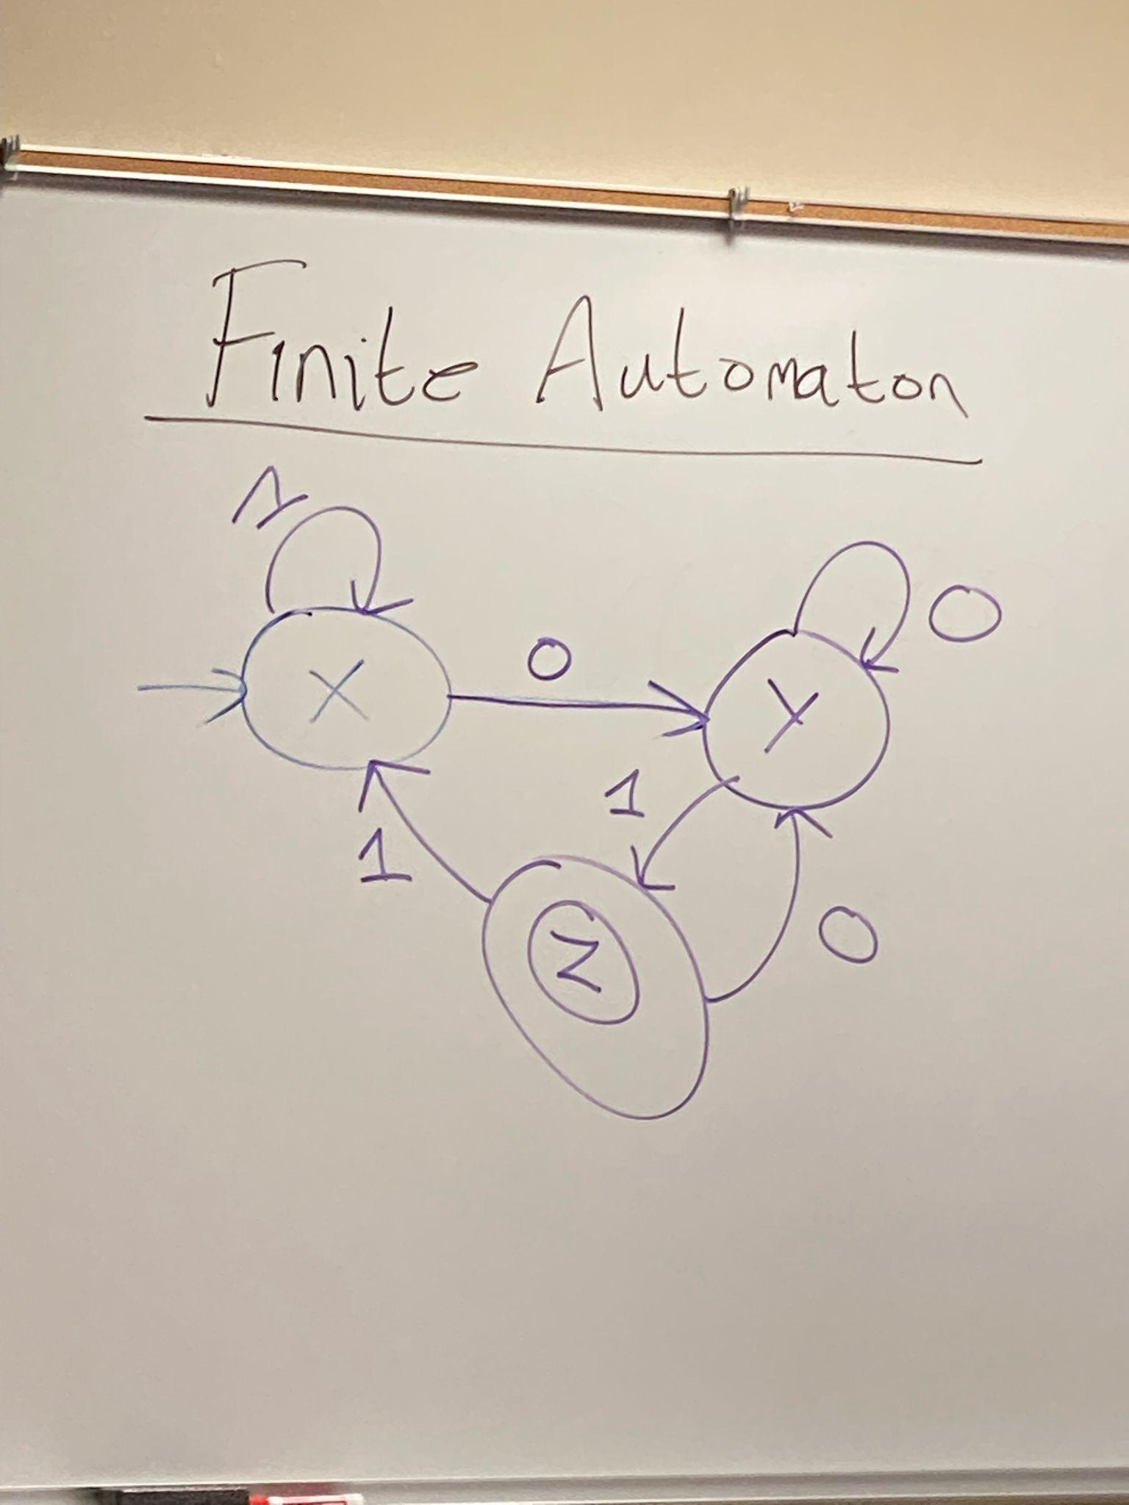
  + Designed to handle strings.
  + Each circle is a state (3 states).
  + The arrows are transitions (6 transitions)
  + The first arrow from nowhere is pointing to the first state.
  + The double ring is the Accept state.
    - All other states are Reject states.
  + Simply a boolean function with an input string.
  + 1010 -> ends in y -> reject
  + 0000 -> ends in y -> reject
  + 1001 -> ends in z -> accept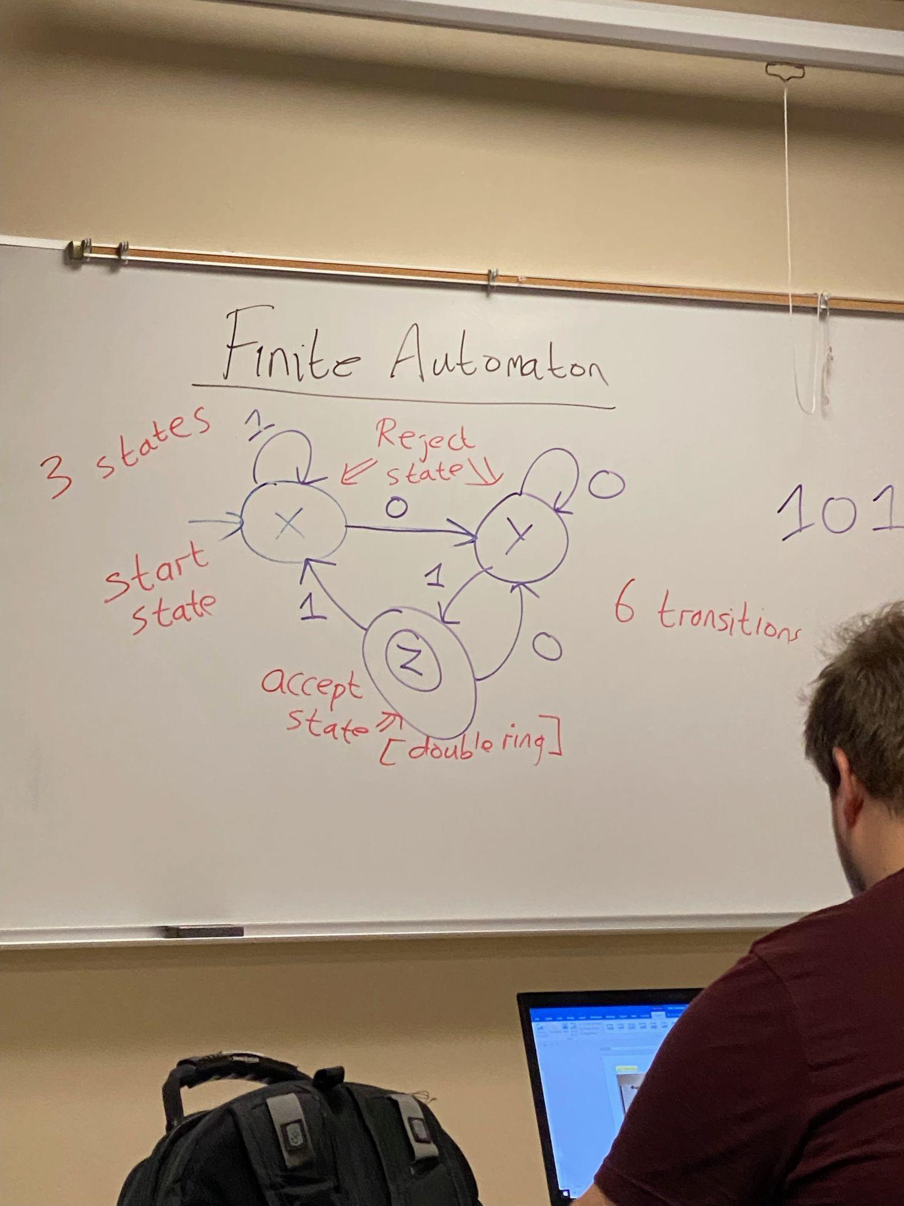
  + There could be all states that are reject states, there also could be all accept states.
  + **QUESTION:** What strings are accepted?
    - The last character must be a 1, the number before the last must be a zero.
    - So, anything that ends in ‘01’ will be accepted.
  + **ANSWER:** All strings ending in ‘01’.
    - When we write the answer, we need to indicate the context so:
      * All strings of 0’s and 1’s ending with 01.
  + This Automaton accepts strings of any lengths, or any possibilities.
* Alphabet
  + Set of characters.
* Language
  + A set of strings.
* String
  + A finite sequence of characters.
* Empty String
  + ε
  + Epsilon symbol to represent an empty string.
* Binary Alphabet
  + 0 and 1.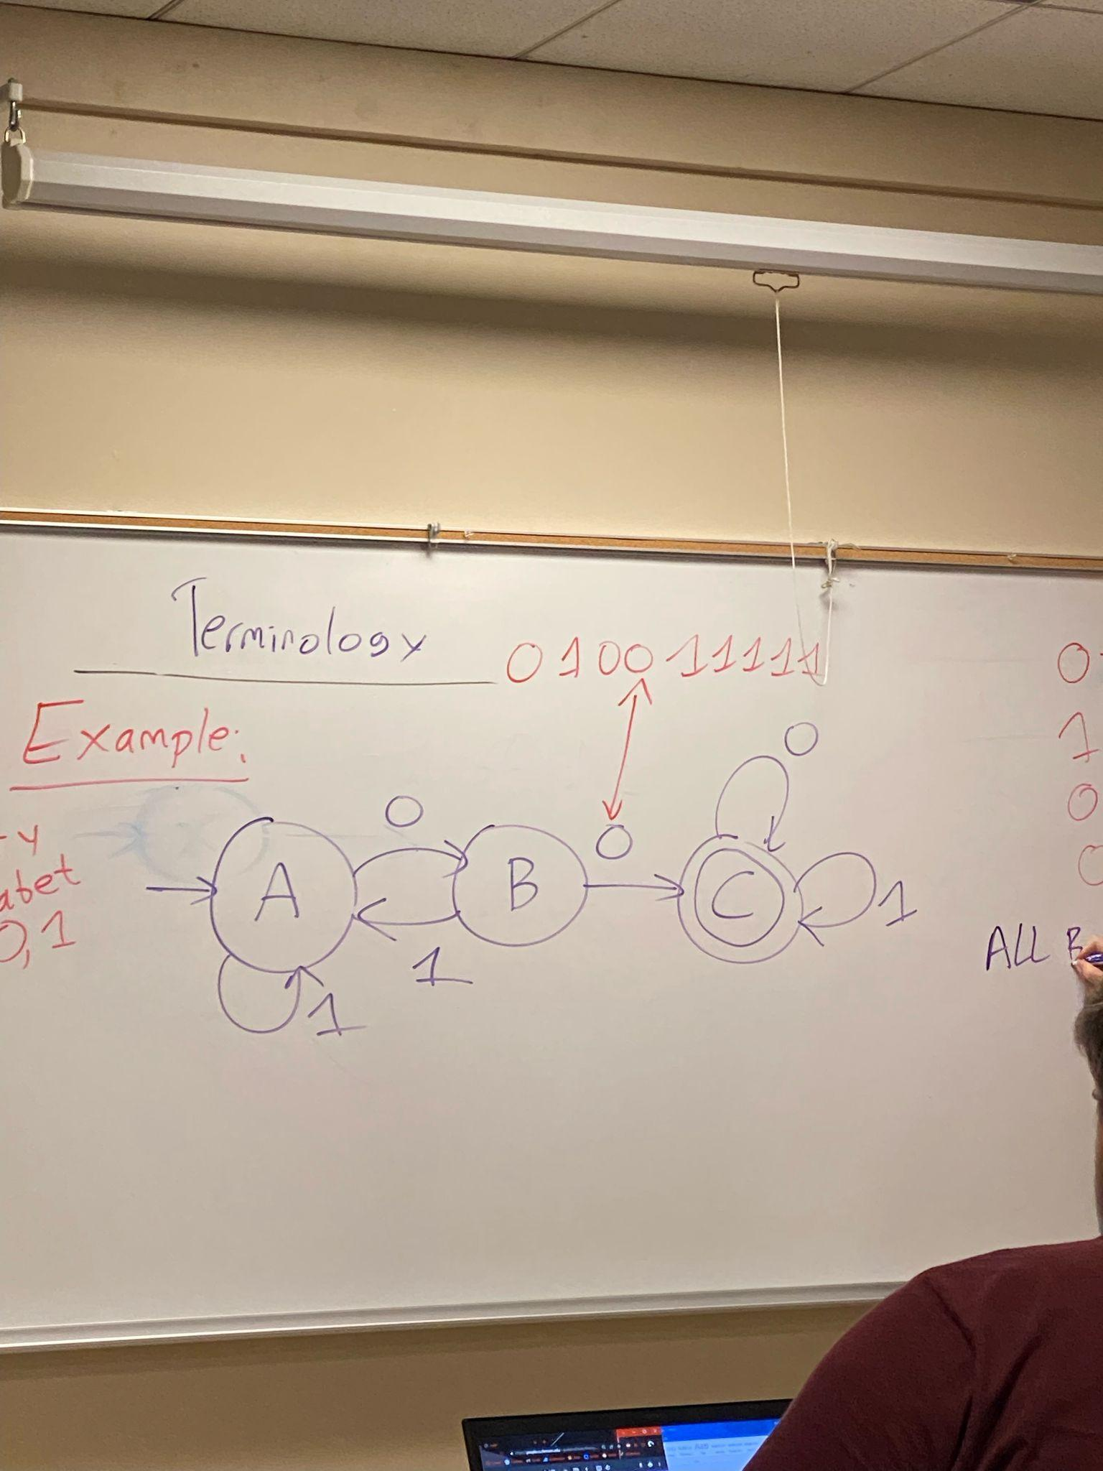
* Example 2:
  + **ANSWER:** All binary strings contain ‘00’ as a substring.
  + 001 Reject, state A.
  + 1010 Reject.
  + 00000 Accept.
  + 001 Accept.

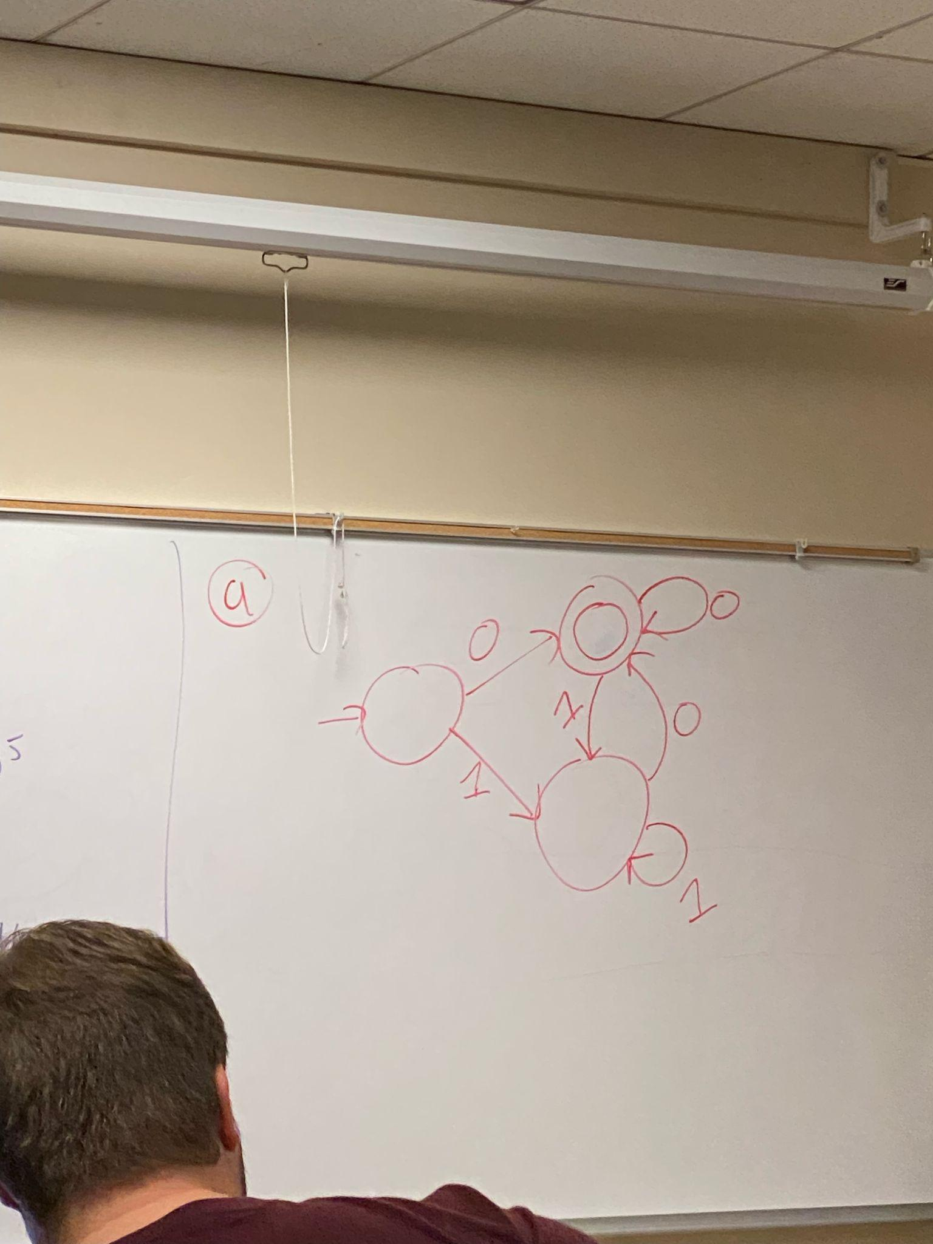

* Example 3:
  + Give FA for all binary strings.
    - A end in 0.
    - B start with 0.
    - C contains 0 exactly once.
    - D does not contain 0.
  + Memory is only its state.
  + We have only done a deterministic automaton.

Textbook Slides: 1

* A finite automaton has a finite set of states with which it accepts or rejects strings.
  + There are three components.
    - Input Tape
      * Contains single string.
    - Head
      * Reads input tape one symbol at a time.
    - Memory
      * Is in one of a finite number of states.
  + Operating an FA:
    - 1: set the machine to start state.
    - 2: If end-of-string then halt.
    - 3: Read a symbol.
    - 4: Update state according to current symbol read
    - 5: Go to Step 2.
  + Final state is state FA is in when finished reading the input string.
  + There are accept states and reject states.
  + An FA accepts input string if final state is an accept state, otherwise it rejects it.
* Alphabet
  + A set of symbols.
* Language
  + A set of strings.
* Language of FA
  + A set of strings it accepts.
* Length of a string
  + The number of symbols
* Empty String
  + Sigma
* Trap
  + A state that once entered, one can never leave. Used to reject partly read strings that will never be accepted, or to accept partly read strings that will definitely be accepted.
* An empty string is in alphabetical order.
  + A string of length one is also in alphabetical order.
* An FA remembers permanently by splitting into pieces.
* Within the scope of the class, 0 is even.